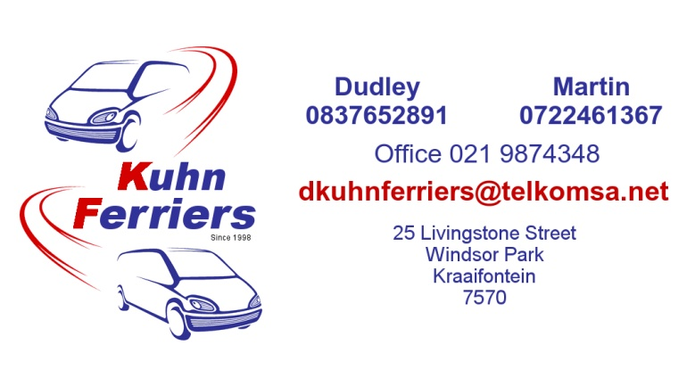

**Booking Form**

Name:

Collection date: Delivery date:

Make and Model of Vehicle:

Reg No:

**Collection:**

Address:

Contact Person:

Contact Number:

**Delivery:**

Address:

Contact Person:

Contact Number:

**Terms and conditions:**

All vehicle owners need to arrange their own insurance.

Kuhn Ferriers is not responsible for any damage that occurs on the trip.

Kuhn Ferriers does not cover any electrical or mechanical breakdowns.

Kuhn Ferriers will refund the client all speeding fines that occur on the trip.

We will try our best to commit to arranged times but due to unforeseen circumstances the driver may run late for the collection or delivery of the vehicle.

**No luggage behind driver or on front passenger seats. Driver needs to be comfortable during the trip.**

**Over loaded vehicles will be charged R500 extra to compensate the driver and extra fuel.**

**Please contact Dudley or Martin if the driver is concerned with the vehicle load.**

**Quoted amount (CASH ONLY) to be handed to the driver upon collection of the vehicle.**

**By completing this form the client accepts the above terms and conditions of Kuhn Ferriers.**